SPARC-Math Grade 2 Integrated Coding-Math Lessons

Unit | Lesson  Number | Robot | Lesson Theme | Time | Description
Introducing Spatial and Programming Language | 1 | None | Programmer Says | 30 min | Students will be able to develop language for coding and space, give commands to a robot as a programmer (input), and demonstrate received commands as a robot (output).
Introducing Spatial and Programming Language | 2 | None | Programmer Says in Pairs | 30 min | Students engage in concepts of space, movement in space, and sequencing (step-by-step instructions) and attach language and symbols to these concepts.
Introducing Spatial and Programming Language | 3 | Cubetto or Robot Mouse | Programming a Robot to Dance | 30 min | Students will be able to develop concepts of space, movement in space, and sequencing (step-by-step instructions) and attach language and symbols to these concepts.
Introducing Spatial and Programming Language | 4 | Cubetto or Robot Mouse | Programming a Robot to Move on a Path | 30-45 min | Students will be able to develop concepts of space, movement in space, and sequencing (step-by-step instructions) and attach language and symbols to these concepts.
Geometry: Creating Shapes with Robots and Loops | 1 | Cubetto or Robot Mouse | Create Square-Shaped Paths | 30 min | Students work with a small group to replicate a secret program that moves the robot in the shape of a square. Students will recognize patterns in their programs and make connections between their programs and the attributes of a square.
Geometry: Creating Shapes with Robots and Loops | 2 | Cubetto or Robot Mouse | Measuring Square-Shaped Paths | 30 min | Students program a robot to move in a square-shaped path and measure each side length. Students will recognize patterns in their programs and make connections between their programs and the attributes of a square. Students will gain understanding of the measure of distance in a dynamic, real-world way.
Geometry: Creating Shapes with Robots and Loops | 3 | Cubetto or Robot Mouse | Create and Measure Rectangle-Shaped Paths | 30 min | Students program a robot to move in a rectangle-shaped path and measure each side length. Students will recognize patterns in their programs and make connections between their programs and the attributes of a rectangle. Students will gain understanding of the measure of distance in a dynamic, real-world way. Students will explore math and coding concepts such as units, iteration, and repetition.

RELATED UTAH CORE STANDARDS
Measure and estimate lengths in standard units (Standards 2.MD.1–4) and relate addition and
subtraction to length (Standards 2.MD.5–6).
- 2.MD.2 Measure the length of an object twice, using length units of different lengths for the two measurements; describe how the two measurements relate to the size of the unit chosen.
- 2.MD.3 Estimate lengths using units of inches, feet, centimeters, and meters.
- 2.MD.4 Measure to determine how much longer one object is than another, expressing the length difference in terms of a standard length unit. For example, after measuring a pencil and a crayon, a student uses the measurements to determine that the pencil is two inches longer than the crayon.
- 2.MD.6 Represent whole numbers as lengths from 0 on a number line diagram with equally spaced points corresponding to the numbers 0, 1, 2… Represent whole number sums and differences within 100 on a number line diagram.
- 2.MD.9 Generate measurement data by measuring lengths of several objects to the nearest whole unit, or by making repeated measurements of the same object.
- Show the measurements by making a line plot, where the horizontal scale is marked off in whole-number units.

Reason with shapes and their attributes (Standards 2.G.1–3).
- 2.G.1 Recognize and draw shapes having specified attributes, such as a given number of angles or a given number of equal faces. Sizes are compared directly or visually, not compared by measuring. Identify triangles, quadrilaterals, pentagons, hexagons, and cubes.

Lesson 1: Programmer Says - Unplugged
20–30 minutes
Objective: Students will be able to develop language for coding and space, give commands to a robot as a programmer (input), and demonstrate received commands as a robot (output).

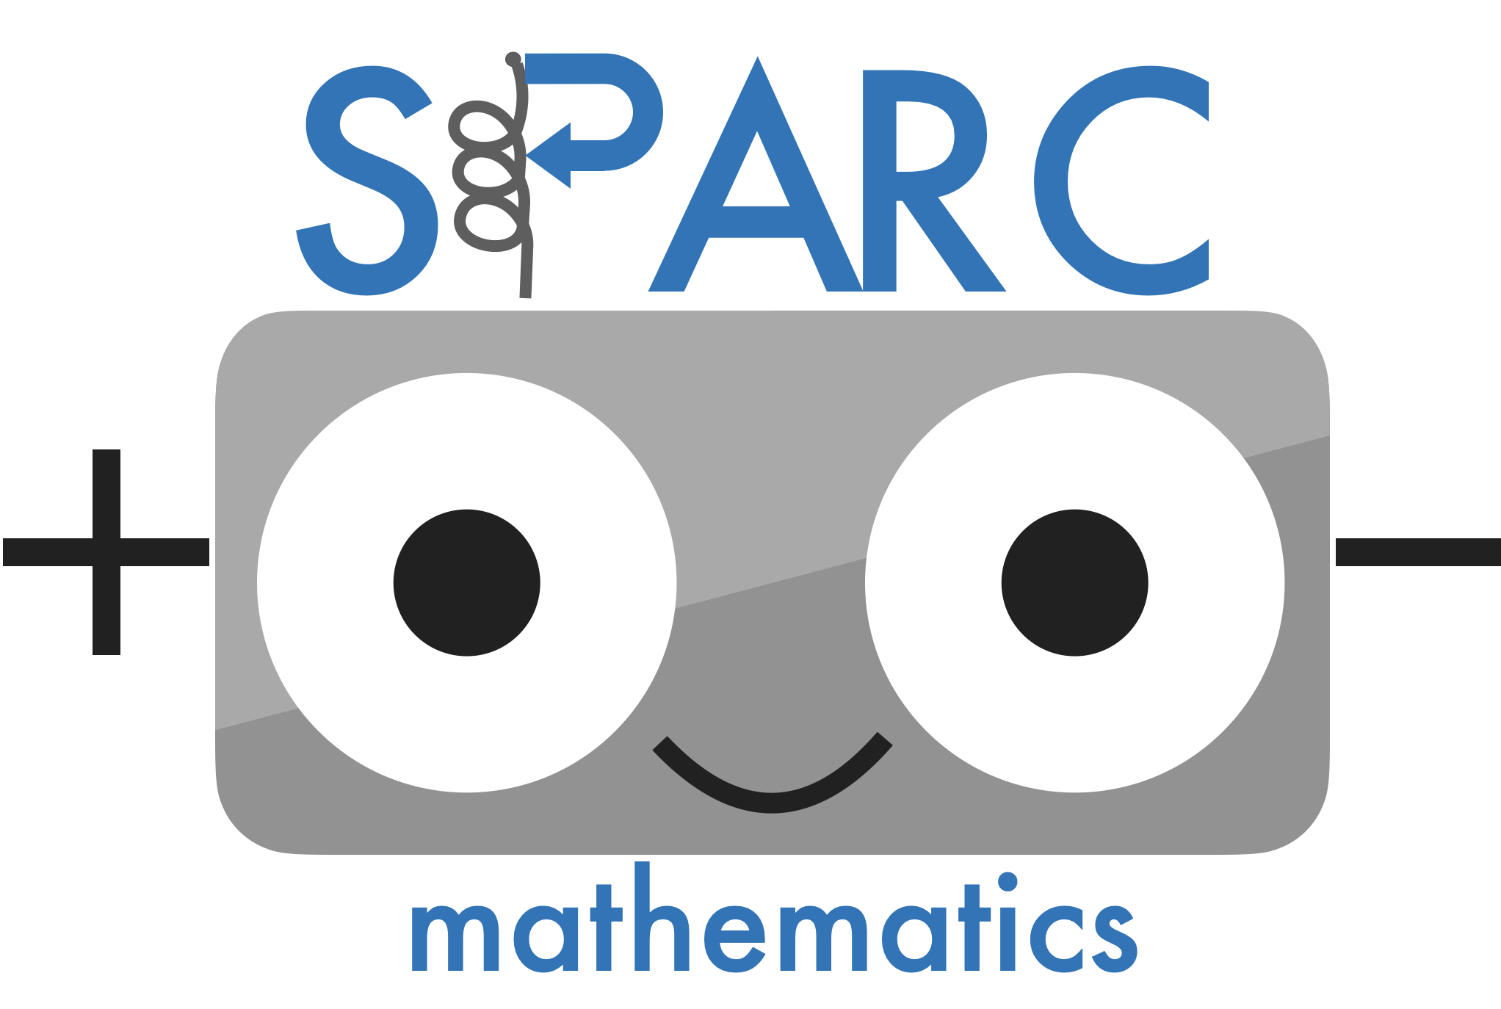 | CT | Algorithmic Thinking  Students will read and enact sequences of instructions. Students will plan sequences of instructions.
 | Math | Spatial Thinking  Students will develop concepts of space, movement in space, and language and codes that represent movements.

Preparation
Materials | Key Vocabulary | Lesson Space
- PowerPoint with vocabulary and sentence frames  - A programmer badge and a robot badge | Forward  Backward  Right rotation  Left rotation  Start and stop  Arrow  Robot  Programmer  Distance  Sequence | Whole Class Lesson

Lesson Preview
 | Purpose | Key Question(s)
Engagement  (5 min.) | To have students access what they know about robots and to learn the names of robot movements. | - Questions: What is a robot? How do robots know what you want them to do?
Main Lesson  (20 min.) | To have students experience the correspondence between the input (a programmer) and the output (a robot). | - Questions: What do you notice about the programmer? What do you notice about the robot? What do the codes do?
Debrief  (5 min.) | To have students explain the correspondence on their own ways and the roles of programmer/robot. | - Questions: What did you learn about programming? What did you learn about being a robot?

Engagement
- Activate students’ background knowledge about robots.
- What is a robot? How do robots know what you want them to do?
- Summarize their ideas. Possible definitions:
  - A robot is a machine that can perform tasks that we instruct them to do.
  - We use a program to tell the robot what to do. A program is step-by-step instructions for the robot.
- Explain the terms code, programmer, and robot.
- We are going to use robots to help us learn mathematics. Before we use them for math, we need to learn a little about coding. Sometime coding is called programming. Today you will be robots and programmers.
- Explain that the codes will instruct the robot how to move. Explain the term sequence.




- Explain/demonstrate the codes.
- Forward and backward
- Rotations
  - *Note: Rotational codes cause the robot to rotate only. They do not move to the left or to the right.

Lesson
Whole Class Activity
- Have four students each stand in a square on the rug. Give them a badge that says “Robot.” Teacher wears the “Programmer” badge.
- Explain that the robots will “Listen, Say, and Do.”
- Listen: Children listen to how teacher read the input sentences
- Say: Children read the input sentences as being the robot (receiving the codes)
- Do: Start the movement only after teacher press the Go button
- Introduce the programmer role and robot role: I am the programmer now and you are the robots. Teacher says and displays each code. Students say each code. Students enact each code.
- Continue this activity with different table groups:
- Forward
- Forward, forward, forward
- Forward, rotate left, forward
- Rotate right, rotate right, rotate right, rotate right
- Rotate right, forward, rotate left, forward, rotate right, forward
Switch roles! Now the students are the programmers, and the teacher is the robot. Teach students to use the new sentence stems.
  - Forward
  - Forward, forward, forward, forward, forward
  - Rotate left, rotate left, forward
  - Forward, forward, rotate right, rotate left, rotate left, forward, forward
  - Forward, rotate right, forward, rotate right, forward, rotate right, forward
- [If time] Introduce the robot for subsequent lessons and enter one of the programs above to command the robot to move. Have students discuss the way the robot moves and imitate the forward, backward, and rotational movements. Discuss the Start and Stop and the robot’s orientation and the students’ own orientation.
  - How are robot movements different from our movements?

I can…

Debrief
- Use the following discussion prompts to debrief the lesson.
  - What do you think a programmer does?
    - A programmer says what the robot needs to do!
  - What do you think a robot does?
    - A robot follows what the programmer said!
    - A robot moves following what the programmer said!
  - What did you learn about being a programmer? Being a robot?
  - Next time, you will do this activity with a partner, and then we will use a robot to help us learn about geometry and measurement.

Lesson 2 Programmer Says in Pairs
30 minutes
Objective: Students will be able to develop concepts of space, movement in space, and sequencing (step-by-step instructions) and attach language and symbols to these concepts.

 | CT | Algorithmic Thinking  Creating and following step-by-step instructions.  One-to-one correspondence  Recognizing that one code results in one action from the robot.  Representation  Recognizing that codes represent actions enacted by the robot.
 | Math | Spatial Thinking  Developing concepts of space, movement in space, and language and codes that represent movements.

Preparation
Materials | Key Vocabulary | Lesson Space
- Codes; arrow cards and arrow sequences  - Sentence frames  - A programmer badge and a robot badge for each pair  - Recording sheets | Forward  Backward  Right rotation  Left rotation  Start and stop  Arrow  Robot  Programmer  Distance  Sequence | Pairs

Lesson Preview
 | Purpose | Key Question(s)
Engagement  (5 min.) | Students access what they learned about codes and robot movements. They learn the activity. | - Questions: What do these codes tell the robot? How does the robot respond?
Main Lesson  (20 min.) | Students experience the correspondence between the input (a programmer) and the output (a robot) during a partner activity. | - Questions: What program did you create? What will it make your robot do?
Debrief  (5 min.) | Students apply their input/output experience and observe the Cubetto robot’s codes and movements. | - Questions: What did you learn about programming? What did you notice about the Cubetto robot?

Engagement
- Introduction
  - Yesterday we learned how to play Programmer Says. I programmed you and you programmed me to move around the rug. Today, you get to create your own programs with a partner.
  - Review the codes and the actions they represent.
- Explain the activity
  - You get to create your own program using 5 codes or less. You have to draw the codes then read each code to your robot.
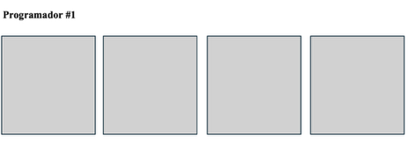
- Model the activity and give one student a Robot badge and one a Programmer badge. Give the programmer a recording sheet to draw their codes. Ask the programmer to “push” the buttons and say each code. The robot moves with each code and says each code. Students will take turns with their partners writing and enacting codes.
- Discuss expectations for working in pairs.

Lesson
- Students are in pairs and determine who is Programmer #1 and who is Programmer #2.
- Programmer #1 puts on Programmer badge and uses the recording sheet to record their program. They push each code and say the code.
- The robot puts on the Robot badge and moves and says each code they enact the program.
- Switch roles! The continue this and explore commands and enactments. Teacher circulates as students work in pairs.

I can…

Debrief
Use the following discussion prompts to debrief the lesson.
  - How did your programs go? What did you learn about being the programmer? The robot?
  - If time, have a few pairs share an interesting program.

Name of Programmer #1______________________________________

Name of Programmer #2______________________________________

Codes

backward right rotation forward left rotation

Programmer #1



Programmer #2

Lesson 3 Programming A Robot to Dance
30 minutes
Objective: Students will be able to program a robot to dance by developing concepts of patterns and repetition, units and unitizing, and sequencing (step-by-step instructions) and attach language and symbols to these concepts.

 | CT | Algorithmic Thinking  Students will create and follow step-by-step instructions.  Repetition, Representation, and Control Flow  Students will recognize that some codes act on other codes (e.g., the Function block calls on the codes in the Function line).
 | Math | Spatial Thinking  Students will develop concepts of space, movement in space, and language and codes that represent movements.  Patterns and Units  Students will use knowledge of patterns, units, and repetition.

Preparation
Materials | Key Vocabulary | Lesson Space
- Cubetto robot, programming board, and tiles  - Robot mouse | Program  Sequence  Unit and Pattern  Function code  Function line | Small groups, each group has a robot.

Lesson Preview
 | Purpose | Key Question(s)
Engagement  (5 min.) | Students access what they learned about codes and robot movements. They become familiar with classroom robots. They learn the activity. | - Questions: What do these codes tell the robot? How does the robot respond?
Main Lesson  (20 min.) | Students experience the coding process with robots. They practice creating patterns in their programs. | - Questions: What program did you create? What will it make your robot do? What pattern makes up your program? What unit of codes is being repeated?
Debrief  (5 min.) | To extend their programming and patterning experience and see programs created by other classmates. | - Questions: What did you learn about programming? What did you notice about the Cubetto robot?

Engagement
1. Introduction
  - Yesterday we played Programmer Says. You and your partner programmed each other to move around the rug. Today, you get to create programs that instruct a robot to dance.
2. Introduce Robot Mouse and review the codes from Programmer Says
3. Introduce Cubetto, the tile codes, and the programming board: have students put 3 codes (RLFB only, for example, RFF) on the programming board and observe what the robot does; do it again with 5 codes. Discuss the observations and codes.
4. Explain the activity
- Cubetto and Robot Mouse are attending a dance party. The robots need the programmers to instruct them to dance.
- Create a FBFBFBFB program for Robot Mouse and for Cubetto. Ask: What do you think this program will tell the robots to do? Have students move their bodies in the way the robots will. Discuss what the instructions say (i.e., reading the program). Ask: What movement pattern makes up this dance?
- Explain that students will have one robot that they need to program a dance, and the dance should have some kind of pattern to it.
- Discuss expectations for working in groups. Divide students into groups of 3.

Lesson
- Students are programming their robots to dance. Notice the patterns they are making. Notice any difficulties students are having with programming (for example, the programming board may be new to them and the curved aspect is difficult).
- As you walk around, ask some groups to share a specific dance. You might also have groups switch robots (e.g., a Robot Mouse for a Cubetto) halfway through the work time.
- Ask questions like:
  - Read your program to me. Can you show me with your body what it will tell your robot to do? Emphasize the word program and that students are creating and reading the program.
  - What is your pattern? Which part is being repeated? How many times will it repeat? Emphasize the word unit and that the unit is the part that is being repeated.
  - Why did you sequence your codes like this? Emphasize their intentional sequencing of codes to make the program.
- For groups that are ready for a challenge and have a Cubetto, introduce the blue tile and the function line as a way to repeat the unit of the pattern. Emphasize the blue tile as the Function code and explain that they are using the Function code to call on the codes in the Function line.

I can…

Debrief
- Come back together as a whole group and choose 2-3 groups to share their programs and robot dance. Select groups that have a clear pattern. Select at least one group that used the Function tile. Use the following discussion prompts to debrief the lesson.
- What patterns do you see in your classmates’ programs?
  - How did your programs go? What did you learn about being the programmer? The robot?
  - What was hard about this activity?
  - If time, have a few pairs share an interesting program.

Lesson 4 Programming A Robot to Move on a Path
30 minutes
Objective: Students will be able to program a robot to move on a path, develop concepts of space, movement in space, and sequencing (step-by-step instructions). Students will recognize that one code leads to one from the robot. Students will attach language and symbols to these concepts.

 | CT | Algorithmic Thinking  Students will read, create, and enact sequences of instructions.  Debugging  Students will find errors in programs and fix them.  If students struggle with this task, one-to-one correspondence of codes-to-movements and/or spatial orientation may be skills to work on (see Formative Assessment Tasks in the lesson).
 | Math | Spatial Thinking  Students will develop concepts of space, movement in space, and language and codes that represent movements.

Preparation
Materials | Key Vocabulary | Lesson Space
- Robot Mouse and Cubetto robots  - Mats for paths (either drawing on a white board or other surface; or the Cubetto Mats)  - Stickers or items for marking start and end points.  - Worksheet | Forward  Backward  Right rotation  Left rotation  Start and stop  Robot  Programmer  Distance  Sequence | Small groups, each group has a robot.

Lesson Preview
 | Purpose | Key Question(s)
Engagement  (5 min.) | Students practice programming their robot to move along simple routes. Students prepare to work in small groups. | - Questions: What codes will we need to include in our program to make the robot follow this route?
Main Lesson  (20 min.) | Students program their robot to follow given routes. | - Questions: What program did you create? What will it make your robot do? How can you fix the bug in this program?
Debrief  (5 min.) | Students will share debugging strategies with the class. Students will discuss difficult programming concepts such as orientation or 1-1 correspondence. | - Questions: What did you learn about programming? What did you learn about debugging?

Engagement
1. Introduction
  - Yesterday we programmed the robots to dance. Review the codes. Today we will program the robots to move along a path. I have some tasks for you to start the robot at one location and end at another.
2. Show an example with Cubetto. Select a path that has at least two forwards, one rotation, followed by at least two more forwards. Work as a class to discuss which codes are needed to move Cubetto on the path.
3. Show one more example, this time with 3 students working in 3 assigned roles: Robot Mover (moves the robot to the start point and places start/end item; shows everyone what they think the robot will do before they run the program), Programmer (places tiles on the programmer board with the other 2 students’ input), and Program Tracker (records the path on the worksheet).
4. Discuss expectations for working in groups. Divide students into groups of 3 and assign roles: Robot Mover, Programmer, and Program Tracker. Explain that they will switch roles for each task.

Lesson
- Students work on at least 3 tasks (up to 5 if they are fast).
- As you walk around, watch for students struggling with one code to one movement or with coordinating the robot’s orientation with their own orientation.

FORMATIVE ASSESSMENT TASK. If one code to one movement is difficult:
  - Place Cubetto on the space of the mat with the cactus on it facing the city. Say to students, Cubetto is near the mountains, the city, the ocean, and the castle. Which location could Cubetto reach with just one code? The only place Cubetto could reach with one code is the city.
    - [If using a robot besides Cubetto, place the robot on the whiteboard surface and draw shapes in front of, to the right of, and to the left of the robot. Ask: Which shape could the robot reach with just one code? It can only reach the shape in front of the robot with one code.]
  - Figure out what codes would be needed to help Cubetto reach the castle, mountain, or ocean.
    - Castle: right turn and forward
    - Mountain: backward, left turn, forward (or two turns, forward, right turn, forward)
    - Ocean: left turn, forward
  - Have students repeat the phrase: “One code, one action.” Emphasize: A rotation code only rotates. To move in a sideways direction, you must rotate and move forward. Extension: Repeat activity with Cubetto in different orientations.
FORMATIVE ASSESSMENT TASK. If orientation is difficult:
- Place robot on mat or whiteboard surface. Draw a shape to the left of the robot, or point out the square to the left of the robot on the mat. Ask: What program will move the robot to land on this shape? Answer: left rotation, forward.
- Now, turn the robot around so it is sitting in the same spot but turned in the opposite direction. Ask: Now what program will move the robot to land on this shape? Answer: Right rotation, forward.
- Ask: Why is the program different when we make the robot face a different direction? Have students practice moving their bodies to face in the same direction as the robot to determine whether a right or left rotation code should be used.

Debrief
- As you walked around, notice the successful and difficult programs and ways students debugged the programs to get Cubetto to follow the correct path. Have 1-2 groups share the debugging.
- Also have students turn and talk to their group about: What did we do well? What was hard?

Names: ______________________________________

Programming a Robot to Move on a Path
Task 1
Cubetto Robot Mouse
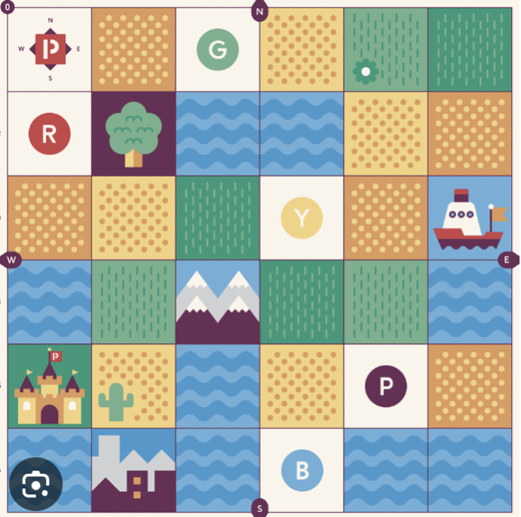

Draw your robot’s route Draw your robot’s route

Task 2
Cubetto Robot Mouse

Draw your robot’s route Draw your robot’s route

Task 3
Cubetto Robot Mouse

Draw your robot’s route Draw your robot’s route

Task 4
Cubetto Robot Mouse

Draw your robot’s route Draw your robot’s route

Task 5
Cubetto Robot Mouse

Draw your robot’s route Draw your robot’s route

Geometry and Measurement Lessons

Lesson 1: Create Square-Shaped Paths
30 minutes
Objective: Students will work with a small group to replicate a secret program that moves the robot in the shape of a square. Students will dynamically interact with the attributes of a square.

 | CT | Algorithmic Thinking  Students will read, create, and enact sequences of instructions.  Debugging  Students will find errors in programs and fix them.
 | Math | Spatial Thinking  Students will develop concepts of space, movement in space, and language and codes that represent movements.  Standard 2.G.1  Recognize and draw shapes having specified attributes, such as a given number of angles or sides.

Preparation
Materials | Key Vocabulary | Lesson Space
- Cubetto programming board ready (but hidden) with FFR FFR FFR FFR  - Robots | Square  Sides and angles  Rotation  Repeat  Pattern  Unit  Distance  Sequence | Whole Class Lesson and Small Group Work

Lesson Preview
 | Purpose | Key Question(s)
Engagement  (5 min.) | Students are engaged in the task by observing the path taken by the robot and speculating about the program. | - Questions: What shape is the path the robot followed? What do you think the secret program is?
Main Lesson  (20 min.) | Students work in small groups to replicate the secret program. They debug and recognize patterns in the program. | - Questions: What is the program? Which codes made the sides of the square? Which codes made the angles? Do you see any patterns in your program?
Debrief  (5 min.) | Students compare their solutions to the solutions of other groups. Students discuss patterns in their programs and relate these patterns to attributes of a square. | - Questions: What is a program for a square route? Which part of the program made the sides/angles of the square? How many times did the pattern in your program repeat?

Engagement
- Have the Cubetto programming board ready (but hidden) with FFR FFR FFR FFR (to make a square-shaped path).
  - I created a program for Cubetto and Robot Mouse. My program tells them to make a shape with their path. I’m not going to show you my program yet. I will run the program, and I want you to notice the shape the robots make with their path. Then, I want to see if you can guess my program and figure out how to make the program yourself.
- Run the program. Have students turn and talk about what they observed.
  - Discuss as a whole class. (It looks like a square-shaped path!)
- Run the program again, and this time have students talk about what they think the program is.
  - Discuss as a whole class. (FFR is repeated four times to make a square-shaped path.)
- Explain that they will work in groups to program their robot to create a square.

Lesson
- As students work in groups, ask:
  - What’s the program?
  - Which codes made the sides of the square? The angles?
  - Take a look at your program. Do you see any patterns?
- If students...
  - struggle with visualizing the sides and angles, use tape to draw the square route so it is easier to see.
  - struggle with following the Robot Mouse program, use the arrow cards for keeping track and seeing the patterns in the program.

Debrief
- Bring students back together and ask:
  - What is a program for a square path for Cubetto?
  - What is a program for a square path for Robot Mouse?
  - Which part of the program made the sides of the square?
  - Which part of the program made the angles? What do you notice about the angles?
  - How many times did the pattern repeat? Why does this matter? (Four repeats and four sides/angles of a square)
- You might use tape to draw the square route so it is easier to see for students that struggled with visualizing the sides and angles. You might also write the program with arrows or letters on the board to emphasize the unit being repeated.
- Emphasize that there is a pattern in the program codes and a pattern in the robot movements. Discuss this to help students coordinate the codes with the space and movement.

Lesson 2: Measuring Square-Shaped Paths
30 minutes
Objective: Students program a robot to move in a square-shaped path and measure each side length. Students will recognize patterns in their programs and make connections between their programs and the attributes of a square.

 | CT | Algorithmic Thinking  Students will read, create, and enact sequences of instructions.  Debugging  Students will find errors in programs and fix them.  Repetition, Representation, and Control Flow  Students will recognize that some codes act on other codes (e.g., the Function block calls on the codes in the Function line). Students will recognize patterns in programs and using robot features (like the Function block) to repeat units of codes.
 | Math | Spatial Thinking  Students will develop concepts of space, movement in space, and language and codes that represent movements.  Standard 2.G.1  Recognize and draw shapes having specified attributes, such as a given number of angles or a given number of equal faces.  Standard 2.MD.1  Measure the length of an object by selecting and using appropriate tools such as rulers, yardsticks, meter sticks, and measuring tapes.

Preparation
Materials | Key Vocabulary | Lesson Space
- Robots  - Rulers or meter sticks  - Recording sheet | Square  Sides and angles  Rotation  Repeat  Pattern  Unit  Distance | Whole Class Lesson  Small Groups

Lesson Preview
 | Purpose | Key Question(s)
Engagement  (5 min.) | Students will access coding knowledge from prior activity and become familiar with the function block. Students will learn the task. | - Questions: What is the repeating unit? How many times does the unit repeat? What patterns do you notice?
Main Lesson  (20 min.) | Students program a robot to move in a square-shaped path and measure each side length. Students will recognize patterns in their programs and make connections between their programs and the attributes of a square. | - Questions: What is the program? Which codes made the sides of the square? Which codes made the angles? Do you see any patterns in your program? How do squares made by Robot Mouse and Cubetto differ?
Debrief  (5 min.) | Students compare their solutions to the solutions of other groups. Students discuss patterns in their programs and measurements and relate these patterns to characteristics of a square | - Questions What programs made square routes? What were your measurements? What do you notice about your measurements?

Engagement
- You used the program FFR FFR FFR FFR to move Cubetto and Robot Mouse in the shape of a square. What patterns did you notice in the program and in the robot’s movements?
- Cubetto has a special code that we can use when we make programs with patterns. The Function block calls on the codes that are placed in this Function line.
- Show students how you move one unit of FFR to the Function line then place 4 Function blocks in the programming line.
  - What is the repeating unit? FFR
  - How many times does this unit repeat? 4 times
- Run the program and discuss.
- Today’s task is to create a square path and measure the sides of the square. When you make a square with Cubetto, using the Function block.
  - Show students the recording sheet to show the Robot Mouse measurements and the Cubetto measurements.
  - Introduce roles: Robot Mover and Tracker, Programmer, and Measurer

Lesson
- As students work in groups, ask:
  - What’s the program? This time, emphasize the lights on Cubetto which show the flow of the program: The Function block light flashes while calling on the codes in the Function Line, then the next Function Block light flashes, etc.
  - Which codes made the sides of the square? The angles? What do you notice about the rotation – what kind of angle does it make? Is it the same every time?
  - Take a look at your program. Do you see any patterns?
  - What do you notice about the size of the Robot Mouse square path compared to the Cubetto square path? How many centimeters is each side?

Debrief
- Bring students back together and ask:
  - What is a program for a square path for Cubetto?
  - What is a program for a square path for Robot Mouse?
  - Which codes instruct the robot to make one side of the square? The angles?
  - What were your measurements? What do you notice about these measurements?
- You might use tape to draw the square route so it is easier to see for students that struggled with visualizing the sides and angles. You might also write the program with arrows or letters on the board to emphasize the unit being repeated.
- Emphasize that there is a pattern in the program codes and a pattern in the robot movements. Discuss this to help students coordinate the codes with the space and movement.
- Discuss differences in the distance each robot moves when instructed to move forward. Discuss the measurements students recorded.

Formative Assessment Task or Extension with Ways to Make a Square
- Introduction: Say: Cubetto is taking an exciting vacation! He’s starting in the castle and will follow a square route that takes him through the desert, the city, and the ocean, and back to the castle. Help Cubetto plan his trip by figuring out how many different programs can be used to move him in along this square-shaped path.
- Activity: Allow students to work in groups of two or three and experiment with different ways to create this square program. Strategically allow groups to share their programs with the group, either throughout the lesson or at the end of each session.
• Possible solutions:
o F R F R F R F R
o F R in function line, Fun Fun Fun Fun in queue
o F R F R in function line, Fun Fun in queue
o F R in function line, Fun F R Fun F R Fun in queue
o F R in function line, F R Fun F R Fun F R in queue
o F R in function line, F R F R Fun Fun in queue
o F R in function line, Fun Fun F R F R in queue
o F R in function line, F R Fun Fun F R in queue
o F R in function line, Fun F R F R Fun in queue
Start/End
o F R F R in function line, Fun F R F R in queue
o F R F R in function line, F R F R Fun in queue
o F R F in function line, Fun R Fun R in queue
o F R F in function line, F R Fun R F R in queue
o F R F in function line, F R F R Fun R in queue
o R F in function line, F Fun F Fun in queue
o R F R in function line, F R F Fun F R in queue
o R F R F in function line, F Fun R F R in queue
o R F R F in function line, F R F Fun R in queue
o R in function line, F Fun F Fun F Fun F Fun in queue
o F in function line, Fun R Fun R Fun R Fun R in queue
- Discussion: Use student solutions to center around the following topics:
• Using the function block to loop or repeat
• Using the function block to recall
• Using function block to make programs more efficient
Possible teacher questions: What is this coding block for (point to the Function block)? Why did you use the Function block here in the program?

Names: ______________________________________

Measuring Square-Shaped Paths

Draw your robot’s square route. Measure each side. Write your measurements next to each side of your drawing.

Cubetto Robot Mouse

Cubetto Robot Mouse

Lesson 3: Create and Measure Rectangle-Shaped Paths
30 minutes
Objective: Students program a robot to move in a rectangle-shaped path and measure each side length. Students will recognize patterns in their programs and make connections between their programs and the attributes of a rectangle. Students will use the function block when coding with Cubetto.

 | CT | Algorithmic Thinking  Students will read, create, and enact sequences of instructions.  Debugging  Students will find errors in programs and fix them.  Repetition, Representation, and Control Flow  Students will recognize that some codes act on other codes (e.g., the Function block calls on the codes in the Function line). Students will recognize patterns in programs and using robot features (like the Function block) to repeat units of codes.
 | Math | Spatial Thinking  Students will develop concepts of space, movement in space, and language and codes that represent movements.  Standard 2.G.1  Recognize and draw shapes having specified attributes.  Standard 2.MD.1  Measure the length of an object by selecting and using appropriate tools such as rulers, yardsticks, meter sticks, and measuring tapes.

Preparation
Materials | Key Vocabulary | Lesson Space
- Robots  - Recording sheet  - Rulers or meter sticks | Square  Sides and angles  Rotation  Repeat  Pattern  Unit  Distance | Whole Class Lesson  Small Groups

Lesson Preview
 | Purpose | Key Question(s)
Engagement  (5 min.) | Students will access coding knowledge from prior activity and become familiar with the function block. Students will learn the task. | - Questions: What is the repeating unit? How many times does the unit repeat? What patterns do you notice?
Main Lesson  (20 min.) | Students program a robot to move in a rectangle-shaped path and measure each side length. Students will recognize patterns in their programs and make connections between their programs and the attributes of a rectangle. | - Questions: What is the program? Which codes made the sides of the rectangle? Which codes made the angles? Do you see any patterns in your program? How do rectangles made by Robot Mouse and Cubetto differ?
Debrief  (5 min.) | Students compare their solutions to the solutions of other groups. Students discuss patterns in their programs and measurements and relate these patterns to characteristics of a square | - Questions What programs made rectangle routes? What were your measurements? What do you notice about your measurements?

Engagement
- You’ve been making square-shaped paths with your robots. This was a program I saw a lot: FR FR FR FR. Some of you changed your program to make a bigger square: FFFR FFFR FFFR FFFR. You’re getting good at this. Could you change your program to make a rectangle? Have students draw the robot’s path again, marking the measurements.
- Have students share ideas with a partner.
- Discuss as a whole class. One example could be FR FFFR FR FFFR
  - What is the repeating unit? FR and FFFR
  - How many times does this unit repeat? How is the pattern different from a square? (you may want to write the codes for the square too – FR FR FR FR – for easier comparison)
- Run one of the suggested programs and discuss.
- Today’s task is to create rectangles and measure them. If you are using Cubetto, use the Function block, but be careful, it will be different this time.
- Show students the recording sheet to show the Robot Mouse measurements and the Cubetto measurements.
  - Introduce roles: Robot Mover and Tracker, Programmer, and Measurer

Lesson
- As students work in groups, ask:
  - What’s the program?
  - Which codes made the long sides of the rectangle? The short sides?
  - Which codes made the angles? What do you notice about the rotation – what kind of angle does it make? Is it the same every time?
  - Take a look at your program. Do you see any patterns?
  - The Function block is different with the rectangle – how did you use it for the rectangle? Why? If students are struggling with using the Function, emphasize the lights on Cubetto which show the flow of the program: The Function block light flashes while calling on the codes in the Function Line, then the next Function Block light flashes, etc.
  - Tell me about your measurements.

Debrief
- Bring students back together and discuss their programs for rectangular-shaped paths.
  - What is a program for a rectangle path for Cubetto?
  - What is a program for a rectangle path for Robot Mouse?
  - Which does made the sides? The angles?
- You might use tape to draw the square route so it is easier to see for students that struggled with visualizing the sides and angles. You might also write the program with arrows or letters on the board to emphasize the unit being repeated.
- Emphasize that there is a pattern in the program codes and a pattern in the robot movements. Discuss this to help students coordinate the codes with the space and movement.

Names: ______________________________________

Measuring Rectangle-Shaped Paths

Draw your robot’s rectangle route. Measure each side. Write your measurements next to each side of your drawing.

Cubetto Robot Mouse

Cubetto Robot Mouse

