How to apply to take endorsement classes:

Go to this website: http://rgs.usu.edu/graduateschool/apply/

Create an account by clicking on Steps to Apply and then on Create an Account.

As you create your account, in the section labeled Demographic Information, you have the chance to indicate when you want to begin.
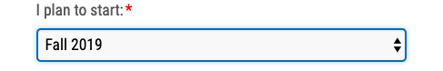

You must also declare what kind of student you want to be:
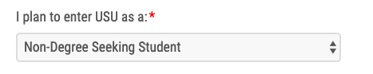

In this dropdown menu, if you only want to take endorsement courses and you DO NOT want to seek a master’s degree, choose Non-Degree Seeking Student.

Under General Academic Area of Interest, look for the endorsement that you are pursuing. For example, Elementary Math Endorsement, Elementary STEM Endorsement, English as a Second Language Endorsement, Gifted and Talented Endorsement, Library Media Endorsement, Reading Endorsement.

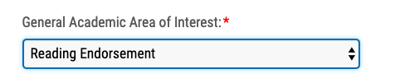

Then, under Where Do You Plan to Study, choose the USU location from which you intend to take classes, or if all the courses you plan to take are online, then choose the USU location that is nearest to you geographically.

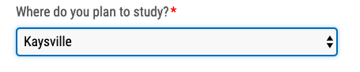

Once you’ve completed all of the information, click Submit and our account will then be generated.

Next you will see this:
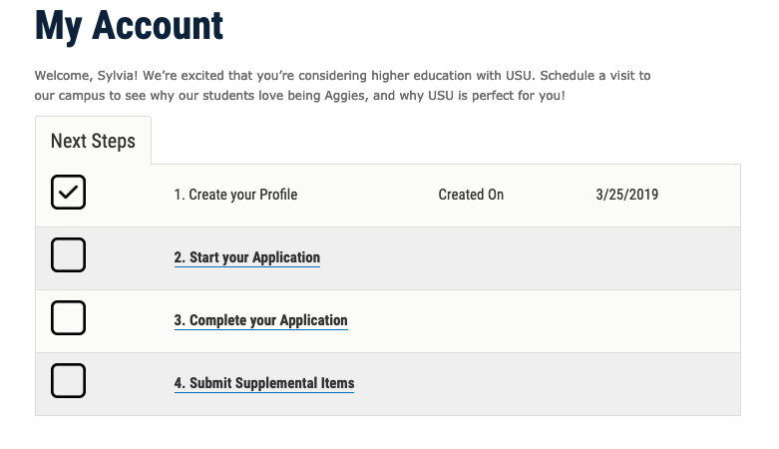

Choose Start Your Application.

Then choose the Non-Degree Seeking Application at the bottom of the next screen.

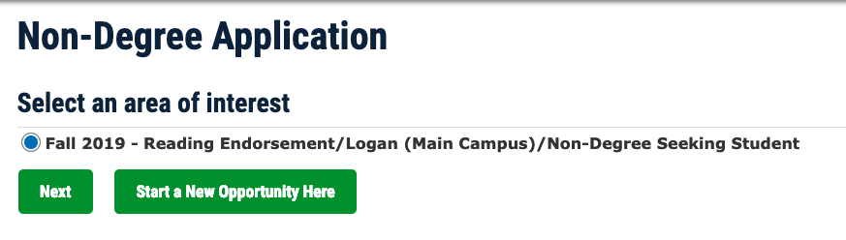
If the semester and endorsement that appear are correct, click Next.

If you need to modify the semester or endorsement, click Start A New Opportunity Here.

On the next page, read the Admission Restrictions. It is important to know that only 12 credits of non-degree seeking credit can be counted toward a degree should you decide to pursue a degree in addition to the endorsement.

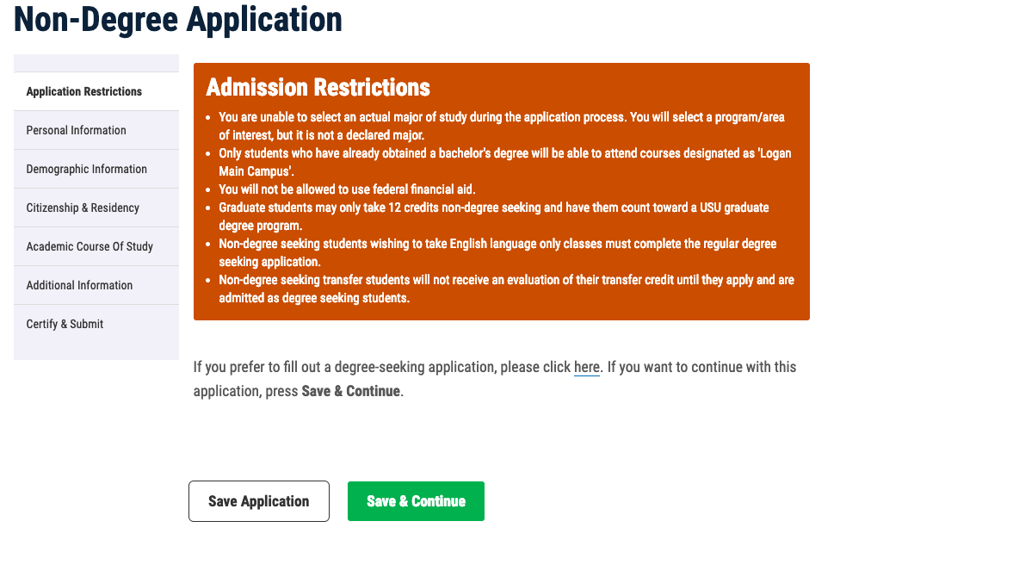

Click through the next screens adding or revising information as needed.

When you get to the Academic Course of Study screen, you will need to indicate your educational intent. Most likely, you will want to choose “Earn Post-graduate Endorsement.”
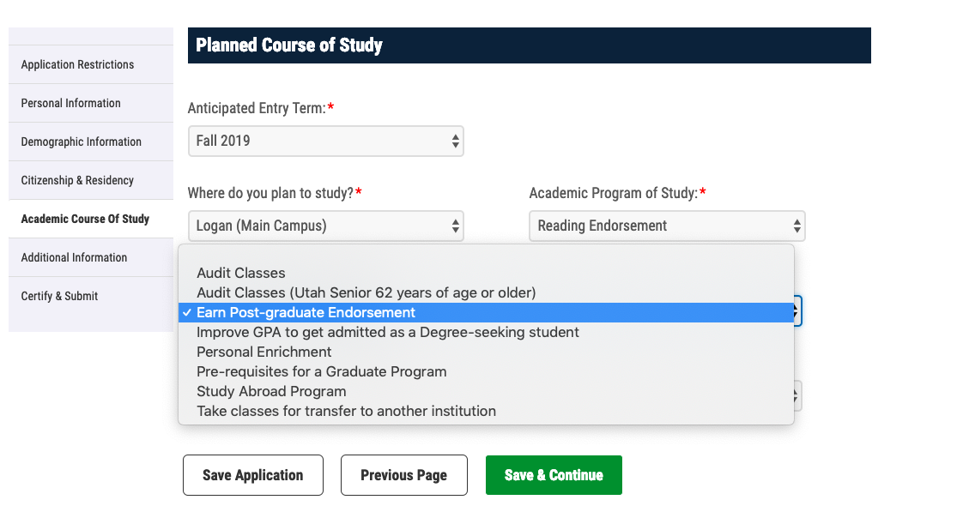

Finally, add any additional information you need to share, then go to the Certify and Subject screen where you will enter your name click Submit Application.

If you have questions about endorsements, please contact:

Dr. Kimberly Lott
kimberly.lott@usu.edu

